Drew Bennett-Litts
3 September, 2026
Debugging Report
I started by running the program in PyCharm to see where the problem was. The program ran fine at first, but it threw an error when it got to the Tablet. I used the debugger and put a breakpoint on the line that calculated the discount. When I checked the variables, I saw that the Tablet price was "500" instead of 500. Because it had quotation marks around it, Python read it as text instead of a number.
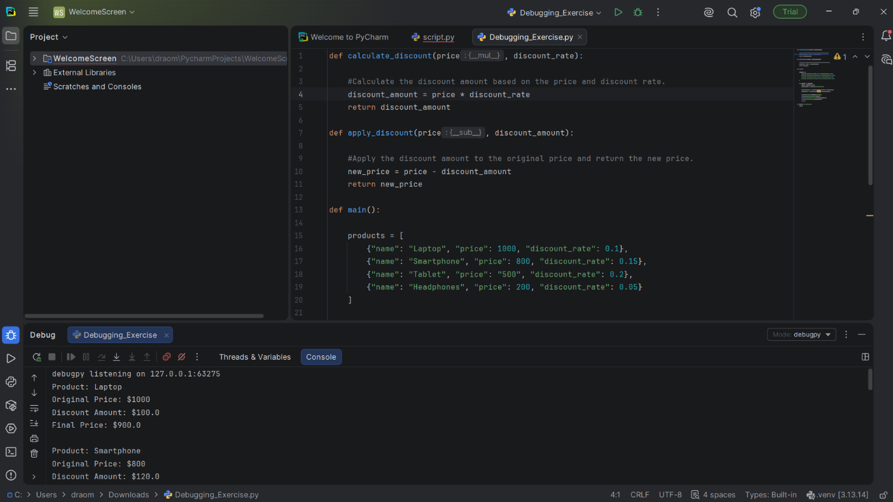
I fixed the problem by removing the quotation marks from 500. I also added a try/except statement so the program could handle bad values without completely stopping.
After making the changes, I tested the program again, and all the products worked correctly. I also changed the Tablet price to "wrong" to make sure the error handling worked. The program showed an error message and continued running instead of crashing. After I finished testing it, I changed the Tablet price back to 500.
The main issue was just the Tablet price being saved as the wrong type of value. Using the debugger made it easier to find and fix the problem.

